MASH Design brief
Date: June 2022

Who we are: | We are MASH  We stand with women who are sex working and support them to experience better health, wellbeing and choices.  Through MASH women who sex work are:  Healthier  Safer  Have improved wellbeing  Have choices available to make positive life changes  Through MASH, in Greater Manchester:  Other agencies are better equipped to effectively support and meet women’s needs  Women who sex work are heard, understood and experience less stigma  Find out more about MASH here https://mash.org.uk/about-us/
The product:
There are four elements to this design project | - Logo/branding refresh  We embarked upon a re-brand prior to Covid and this was paused. However, we did not want to postpone the much needed redevelopment of our website.  With this in mind we have introduced new brand colours, fonts and a ‘look and feel’ however we are currently still using our old logo.  We require a designer to take forward the work and consultation which has already taken place to create two branding options which we will put to our service users and teams to influence the final decision. A suggestion is that one of these options is a refresh of our current logo.  The designer will then take this forward, finalise and provide the final logo in relevant formats for use on marketing collateral.  For reference here is our impact report which uses our new colour palette and design feel but there is scope to develop and change this  https://mash.org.uk/wp-content/uploads/2021/11/MASH-Impact-Report-2021-FINAL.pdf  - Designed up document of MASH’s new strategy  Once the branding is agreed, we required a designed up document of MASH’s new five-year strategy.  This is currently a 10-page MS Word document.  - MASH’s strategy on a page  We also require an impactful, engaging and user-friendly ‘plan on a page’ version of our strategy which will be the public-facing version of this document and shared with our service users etc. Probably much more graphic in style  - Suite of marketing collateral  Featuring new branding including powerpoint template, letter head, email signatures, editable Canva social media graphics, posters, flyers
Target audience:  - Who is this product aimed at?  - What are you asking your audience to think, feel and do?  - Include audience profiles  - What change do you want to see as a result? (awareness raising, inform, drive behaviour) | - All MASH audiences e.g. service users, donors, other agencies and charities, volunteers  - Stakeholders e.g. funders, commissioners, local authorities – So they know MASH’s ambitions, our expertise is cemented, they understand the vital work we do and that it should be valued and supported  - Public audiences e.g. service users, volunteers, donors - MASH is transparent about what we do, how we do it, our future ambitions etc. People feel connected to our ambitions
Lifetime  - What is the product's shelf life? | 5 years
Distribution/promotion  - Where will the product appear?  - How will you promote it? | - All public facing MASH channels including website, presentations, lanyards, MASH van etc.  - Website and emailing specific contacts  - Website, printed copies at MASH
Artwork specifications
Format | - Strategy: PDF doc/ A4 if printed. Page no tbc depending on design but correct numbers for printing  Further details to be discussed/agreed at the start of the project
Brand guidelines | These are our new colours  #255D83  #735983  #CC6686  #FF687E  #FFAF87  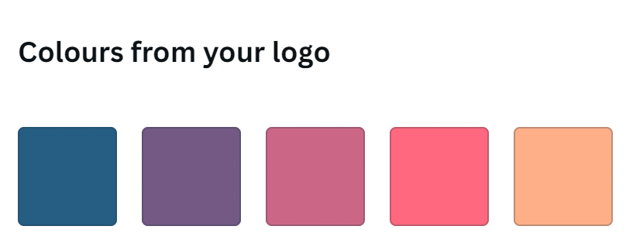
Images | We have a library of photographs, many of which can be seen on the MASH website and in the impact report
Copy | We will provide copy for the strategy and the plan on a page
Key milestones
Deadline for first proofs | - Options for branding by w/c 22 August. Final sign off by end of September  2./3./4. Drafts to be provided by mid-October. For November launch
Next steps | To be considered for this project, please send some relevant examples of your work to Janelle Hardacre janelle@mash.org.uk and a covering email detailing how your expertise and approach meets our brief.  The email should include;  - Your approach and suggested timeline for the project  - Your budget  - Why you are best suited for the project  The deadline for responses is Wednesday 13 July at 5pm.  Shortlisted designers be contacted w/c 18 July and the designer will be appointed by w/c 25 July.  The work will be completely remotely and the individual must have the equipment and software required to complete the brief.
Budget | Our budget for this project is around £1800 - £3,000

